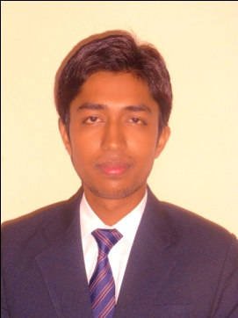
C/o-JAIRAM PASWAN,
B-1/18 Gali no.2
New Ashok Nagar
Delhi- 110096
Pawan.paswan90@gmail.com
+918826953594

PAWAN PASWAN

Career Objective  Educational  Qualification  Computer Skills  Summer Internship  Specialization  Academic projects  Extra Co-Curricular  Activities  Hobbies & Interests  Personal Details: | Enthusiastically work for an organization for its development and enhance my own skill and knowledge.  - Master of Business Administration(MBA):  - Birla Institute of Technology, Mesra passed in 2015 Aggregate 75.4%  - Bachelor of Business Administration(BBA):  - IIMT college of Management, affiliated to CCS  University Meerut, passed in 2012 Aggregate 63.33%  - Intermediate.  P.K Roy Memorial College, Affiliated to J.A.C, passed in 2009 Aggregate 48.8%  - Matriculation.  D.A.V High School, Affiliated to J.A.C, passed in 2006 Aggregate 67.2%  Operating systems : Windows XP/7  Applications : MS Word, PowerPoint, Excel  - 45 day summer internship in AC NIELSEN.  - Project title: “Retirement research-2013”  - Human resource management.  - Marketing management.  - “Impact of motivation on retention in HEC Ltd. Ranchi”  - Research Analysis on “Comparison between Samsung as a Brand and Samsung Laptop as a Brand”  - Designing Advertising Campaign for”Vicco turmeric cream”  - Participated in Cricket.  - Participated in Entertainment Quiz Organized by BIT MESRA.  - Participated in IGNEOUS 2011 held at IIMT College of Management.  - Playing Cricket.  - Listening Music  - Spend time on PC  - Travelling  - Date of birth : January 20, 1990  - Age : 25  - Gender : Male  - Language Known : English, Hindi  - Nationality : Indian

DECLARATION
I hereby declare that the above-mentioned information is correct up to my knowledge and I bear the responsibility for the correctness of the above-mentioned particulars.

Date:
Place: SIGNATURE

